Analysis employee data
Estarta solutions traning
Done by: Aya Zaitoun

29/4/2026
2026
Introduction:
This report presents a data-driven analysis of the company's employee dataset, which contains information on 1,000 employees across 7 departments and 3 countries. It aims to provide the management team with clear insights into employees distribution, patterns, and potential inequalities among employees, in order to support better and more informed decision-making.
Objectives:
- To help management team with decision-making.
- Analyze employees distribution across departments, business unit, countries.
- Perform Performance Evaluation
- transforming raw data into actionable insights
Visualization:
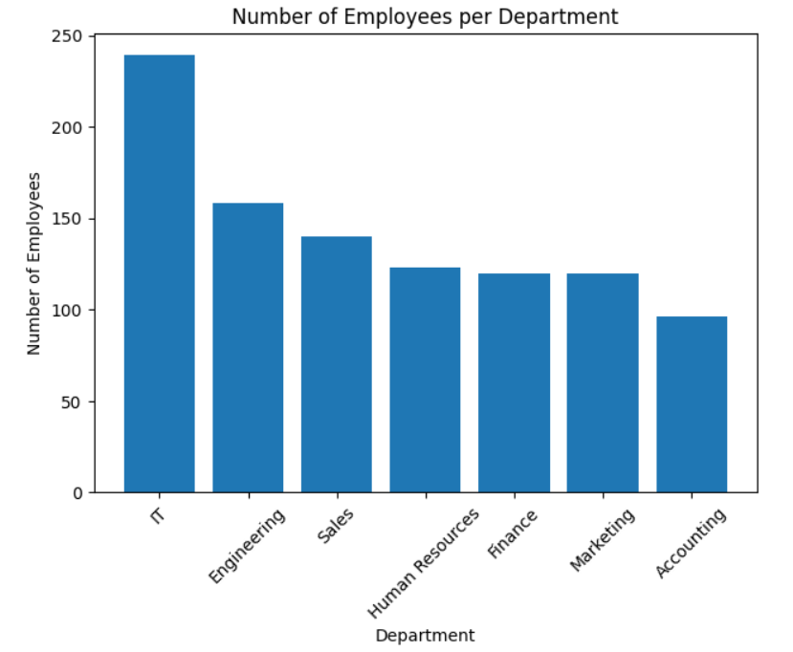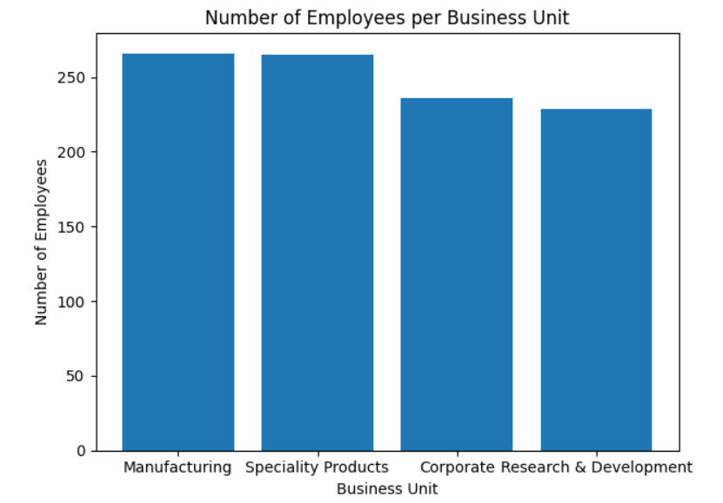
Figure 1 number of employees per department Figure 2 Number of employee per business unit
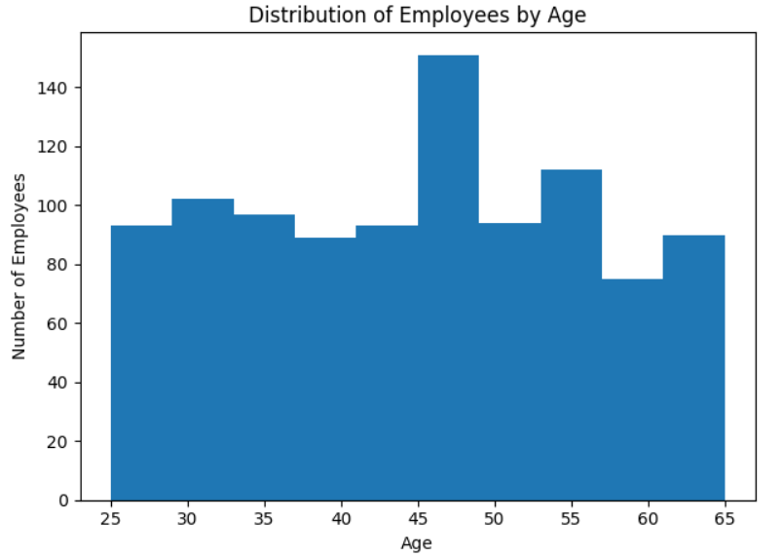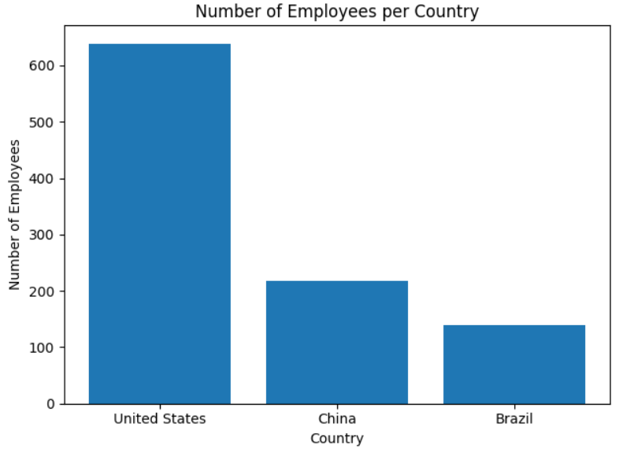
Figure 3 distribution of employees by age Figure 4 number of employees per country

The graphs shows us that is the largest department is IT while Accounting is the smallest, reflecting the company's technology-driven focus. Across business units, employees are relatively evenly distributed. The most frequent age range is 45-55, indicating a mature and experienced workforce, though this may suggest a future need for younger talent. The United States accounts for the majority of employees, while China and Brazil may require increased hiring efforts to better balance the global workforce.

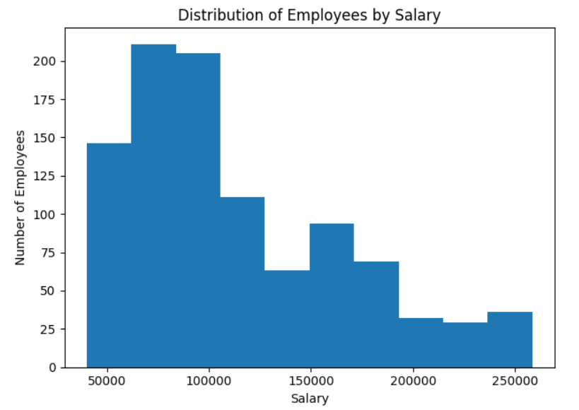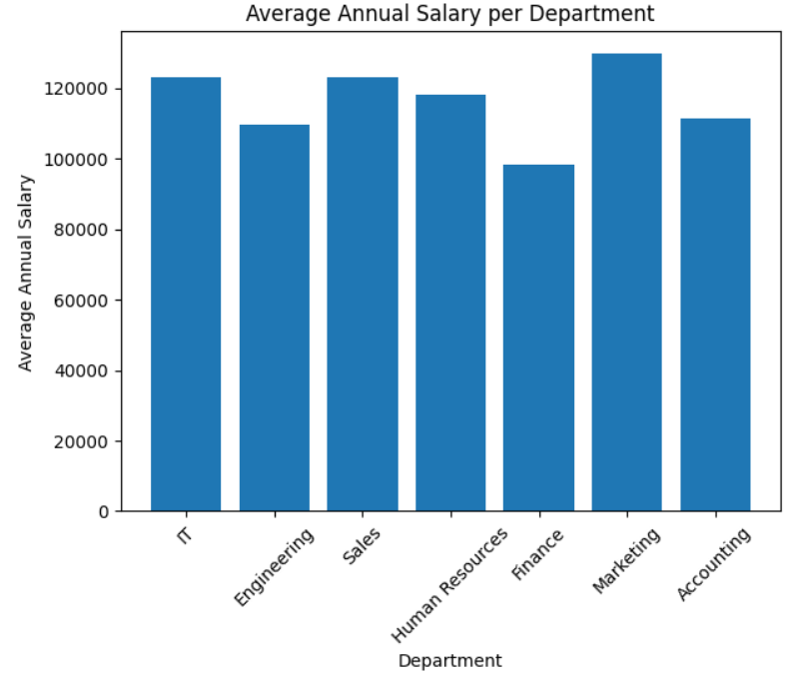
Figure 5 distribution of employees by salary Figure 6 average annual salary per department
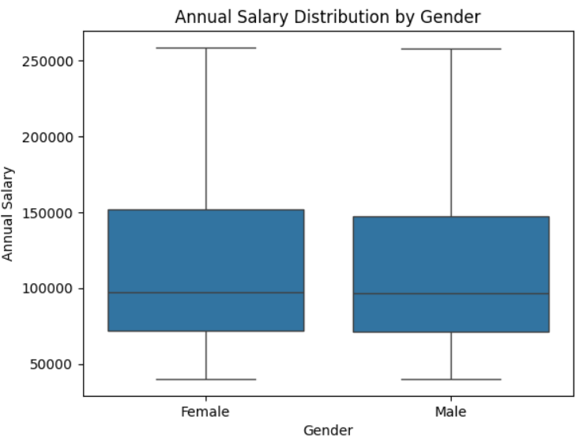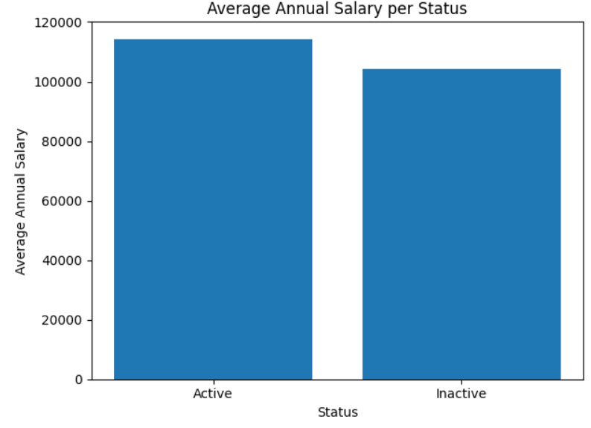
Figure 7 annual salary distribution by gender Figure 8 average salary for employee status

Employees salaries range from 50,000 to 25,000 and the distribution a shows us a little right skewed, indicating that the majority of employees earn between 50,000 and 100,000, while a smaller proportion receives significantly higher salaries. Marketing and IT department the highest average salaries, and other salaries distributions almost balanced.

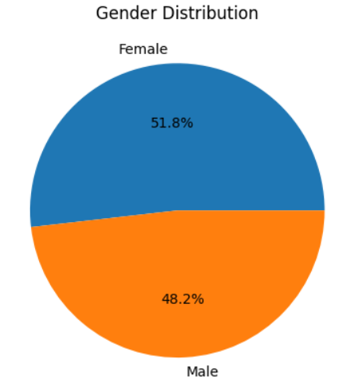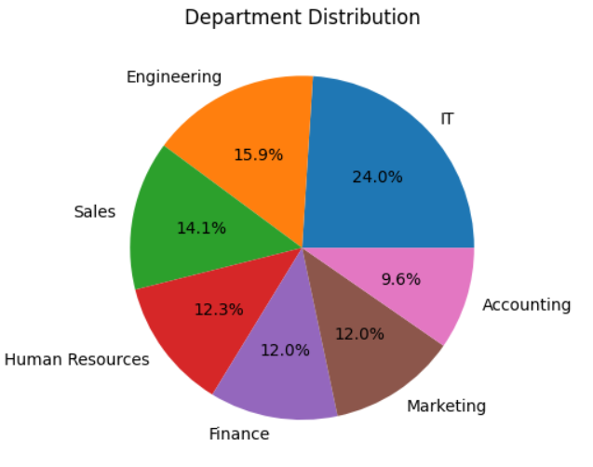
Figure 9 Gender Distribution Figure 10 Department distribution

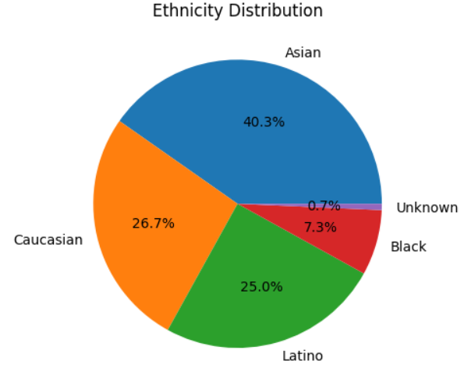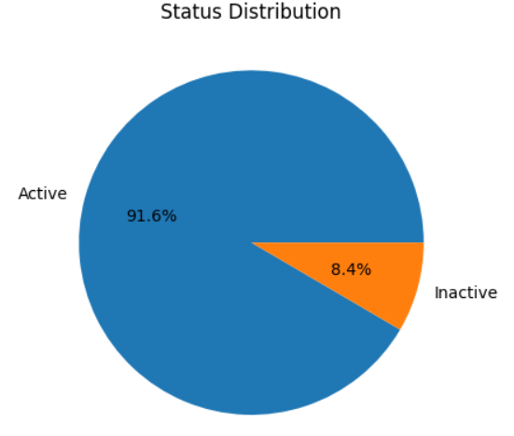
Figure 11 Ethnicity distribution Figure 12 Employee status distribution

The percentage of number of employees left the company is 8.4% while the 91.6% still active so I compared the average salaries to see if it is behind the reason percentage but the average salaries indicates that other non-financial factors, such as career development, work environment, or management practices, may be influencing employee exits and should be explored further by the management team.

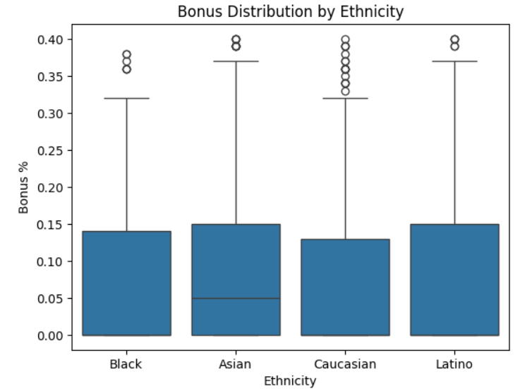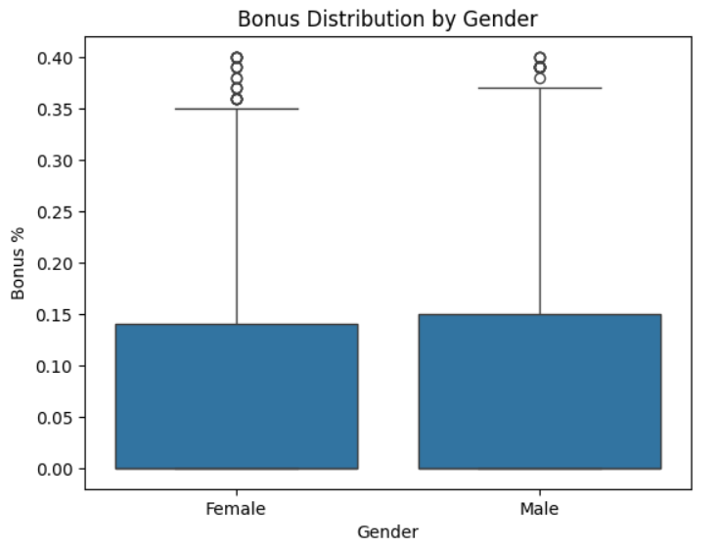
Figure 13 Bonus distribution by ethnicity Figure 14 Bonus distribution by gender

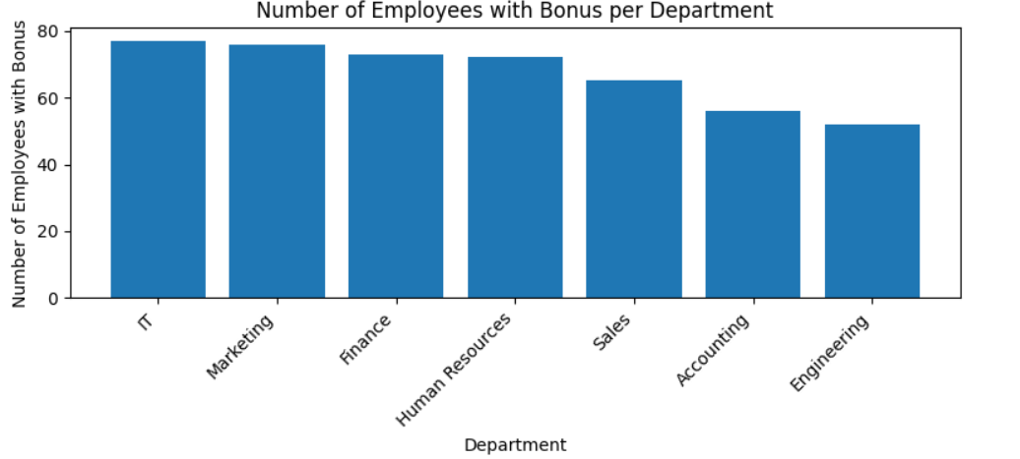
Figure 15 number of employees with bonus per department

The overall difference is modest, also there is some outliers indicate that certain individuals receive significantly higher bonuses. The management team may consider establishing a standardized bonus framework across departments to promote equity and transparency.
Conclusion:
Overall, the company demonstrates a well-structured and relatively balanced workforce across departments, business units, and genders. However, several areas warrant management attention. The aging workforce suggests a need to attract younger employees to ensure long-term sustainability. While turnover remains low at 8.4%, the absence of a salary-related cause indicates that non-financial factors should be investigated. Finally, standardizing the bonus allocation policy and increasing hiring efforts in China and Brazil would contribute to a more equitable and globally balanced organization.

